Online Presentation Video Guidelines for Poster Presenters

- All the presenters are required to prepare a pre-recorded video presentation limited to 02 minutes (Maximum presentation time is 03 min).
- Please kindly use Zoom software for the video recording purpose to ensure consistency of presentations.

Recording a Zoom Based Presentation
This guide will assist you in preparing your video presentation; for additional information, visit the “Video recording guide” video on the IRCUWU2025 web.

- Prepare your poster using the PowerPoint template given on the conference web.
- Create a Zoom account (including in the free version) using https://zoom.us/, or if you already have one, log in to your account with the Zoom app. (The free account will give you recording time approximately upto 40 minutes)
- Open your presentation and go to presentation mode.
- Go to the Zoom app and ‘Start New Zoom meeting’. Then, select ‘Join with computer audio’, and unmute your microphone and turn ON the video camera icon at the left-bottom of your screen.
- Download the virtual background from the conference web and select it as the virtual background of Zoom.
- In the Zoom toolbar, click the ‘Share Screen’ option and select the ‘Screen’ option. (You may click on your PowerPoint presentation to share your presentation).
- You will get your PowerPoint presentation through the Zoom window; minimize other windows opened, if any.
- Drag and drop your image onto the presentation's designated area, i.e., the right top of the screen. When everything is ready, you should see a screen similar to the one below.

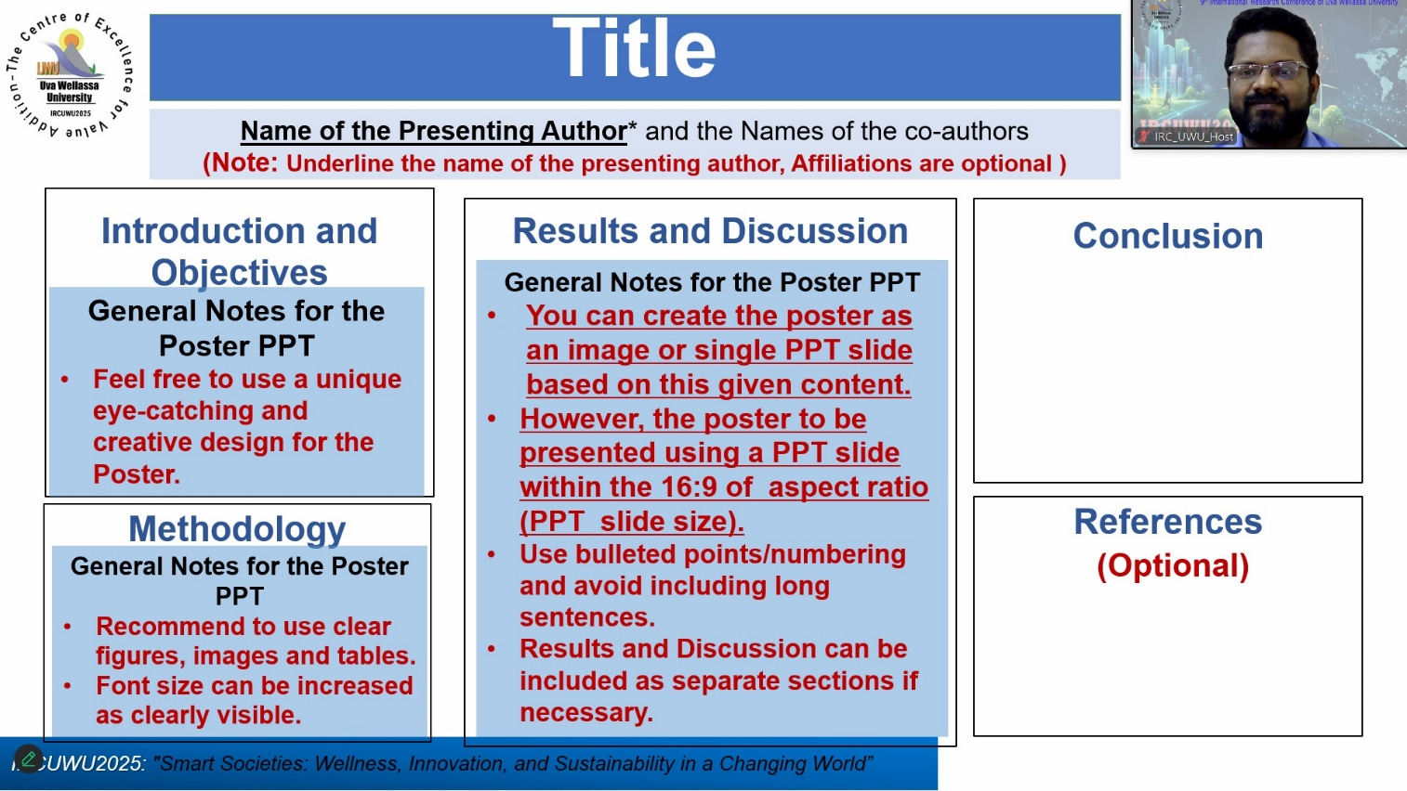

- You may select ‘Laser pointer’ from the tools at the bottom left of your window (or use the cursor as the pointer).
- Next, click ‘Record’ in Zoom (it may be under the ‘More’ button). You can also start recording by pressing the Alt+R keyboard shortcut. When you click ‘record, it will begin recording; you may start to present your work. Make sure that the video camera and the microphone are ON in the Zoom software.
- When the presentation is over, press the ‘Stop Recording’ button or the Alt+R key combination once more.
- Go to ‘More’ and click ‘end’. Then click on ‘Leave meeting for all’.
- Wait for the ‘Convert Meeting Record’ process to complete. It will be saved on your computer, and Zoom will open the recording folder after the video has been processed.

Note
- Select a noise-free location with plain background for your video recording or we recommend using a headset, so you won’t get laptop fan noise etc. during the recording process.
- Play and check your video before submitting us.
- The organizing committee to IRCUWU2025 will preview the recording for quality and ask you to re-record if necessary.
- Kindly keep general ethics while selecting your attire.

Saving and Submitting Presentation

- Go to the location of the video file. It is mandatory to save your recorded video presentation in MP4 format. Please rename your recording video by the abstract/paper ID number (use Paper ID number with 3 digits) and mode of presentation before submitting. Eg: IRCUWU_ID_001Poster
- Email or upload (through CMT) the MP4 version of your video presentation and PPT to the appropriate track organizers. The authors will be notified of the submission email, in special circumstances.

At the Conference Day

- The online poster presenters should be present during your presentation slot, especially for the Q&A Session (Around 02 Minutes Q&A).

