TITLE OF THE STUDY PRESENTED IN THE ABSTRACT
(Title of the extended abstract should be the same as that of the abstract submitted. The title should appear in the correct style (All Caps, 12pt. Times New Roman, boldface, left-justified).)

INTRODUCTION (All Caps, 12pt. Times New Roman, Boldface, left-justified)
It should provide background information about the work and its significance while highlighting other relevant literature and specifying how it relates to or differs from your work. It would be best if you also discuss the scope and limitations of your study in the introduction. Please cite relevant sources as evidence for or justification of an argument or statement.
The manuscript text should be single spacing, 12pt, Times New Roman font, justified. All illustrations must be designed inside of the main text.
RESEARCH PROBLEM(S)/ISSUE(S) (IF RELEVANT) (All Caps, 12pt.
Times New Roman, Boldface, left-justified)
In this section, you might mention specific issues, difficulties, contradictions, or gaps in knowledge that you will address in your research. You might look for practical problems aimed at contributing to change or theoretical issues aimed at expanding knowledge.
The manuscript text should be single-spaced, 12pt, in Times New Roman font, and justified. All illustrations must be designed inside of the main text.
OBJECTIVE(S) (All Caps, 12pt. Times New Roman, Boldface, left-justified)
Provide a clear statement/s of goals and objectives/specific objectives of the project that should be understandable to reviewers/scholars from various other disciplines.
The manuscript text should be single-spaced, 12pt, in Times New Roman font, and justified. All illustrations must be designed inside of the main text.

THEORETICAL CONSIDERATIONS AND EMPIRICAL EVIDENCE
(IF RELEVANT) (All Caps, 12pt. Times New Roman, Boldface, left-justified
Provide details on specific and major theoretical aspects here (if relevant).
The manuscript text should be single-spaced, 12pt, Times New Roman font, and justified. All illustrations must be designed inside of the main text.

METHODOLOGY (All Caps, 12pt. Times New Roman, Boldface, left-justified)
The methodology section should be descriptive enough that the reader can identify what was done. References to the methodology are appropriate. Within the methodology section, you can apply as many first-, second-and third-level headings as you need.
The manuscript text should be single-spaced, 12pt, Times New Roman font, and justified. All illustrations must be designed inside of the main text.
All illustrations must be designed inside of the main text.
RESULTS AND DISCUSSION (All Caps, 12pt. Times New Roman, Boldface, left-Justified)
In this section, you may include a description of the main findings of the research, using data, figures, tables, etc. Also, interpretations of the results for readers and provides the significance of the findings in the discussion section with appropriate references. Note that the results and discussion should amount to 50% of the extended abstract. The findings/results and discussion sections may be combined. Within the results and discussion section, you can use as many first-, second, and third-level headings as you needed.
The manuscript text should be single spacing, 12pt, Times New Roman font, justified. All illustrations must be designed inside of the main text.
All illustrations must be designed inside of the main text.

CONCLUSION(S) (All Caps, 12pt. Times New Roman, Boldface, left-justified)
Write a concise paragraph pulling everything together to help clarify the research work and remind the reader of the main arguments and their importance. You can also suggest possible future research on the topic.
REFERENCES (All Caps, 12pt. Times New Roman, Boldface, left-justified)
References should be cited within your extended abstract using the Harvard Referencing style. Examples of reference formats are given in the Specific Guidelines sections. For additional information on formatting references, refer to the "Referencing Guidelines" under the "Quick Links" section on the IRCUWU2024 website.
Extended Abstract Preparation - Specific Guidelines

Extended Abstract Length
Extended abstracts should be at least three pages, but not more than five A4 size pages in length, including the references. The word limit is 1500 - 2,000 words.

Using Predefined Styles
The style elements identified in this section have been defined for you to lend consistency to the group of papers. Times New Roman is the preferred font type.
All abstracts should be written in English language using MS Word (.docx/.doc format) or appropriate tool/software. You must submit a Portable Document Format (PDF version) of your abstract for review.
Use the following levels of this font type to describe the different sections of your extended abstract;
- Title: All Caps, 12pt. Times New Roman boldface, left-justified
- Author: Not Applicable
- Heading 1: 12-POINT TIMES NEW ROMAN BOLD, ALL CAPS
- Heading 2: 12-Point Times New Roman Bold
- Heading 3: 12-Point Times New Roman Bold
- Normal (body) text: 12-point Times New Roman, Justified
- Paper Size: A4
- Margins: 1 inch for left and right, and 0.75 inches for down, 1.5 inches for up
- Line Spacing: Single
- Spacing Before and after: 0
- Number of Pages: Minimum three and maximum five including references
- Spellings: British style
- Non-English and Technical Terms: In italics
- Figures: See figure format for more information
- Tables: See table format for more information
- Text: Justified
- Page numbering:12pt, Times New Roman, Bottom-Right

TABLE FORMAT
Tables must be created using the Microsoft Word or WordPerfect table functions and included as part of the text immediately after the first point of reference. DO NOT place them at the end of your extended abstract. For improved readability, keep your tables as simple as possible. All the tables should use only three horizontal lines (no lines to separate columns) and be centered in the main body/text.
Table 1. Title of the table (12-point Times New Roman, table title should appear immediately above the table)
Month | Jan. | Feb. | Mar. | Apr. | May. | Jun.
Arrivals¹ | 0,000 | 000 | 00,000 | 000,000 | 000 | 00,000
Departures | 0,000 | 000 | 00,000 | 000,000 | 000 | 00,000
Total | 0,000 | 000 | 00,000 | 000,000 | 000 | 00,000
¹Bulleted and numbered lists should be created using the word processing toolbar functions for these items (10pt, Times New Roman, left-justified)
Any explanations of table data should immediately follow the table and be formatted as plain body text. DO NOT include table explanations within tables. Notations and references, such as superscript letters and number notations, are acceptable within the table. A legend describing notes should follow directly underneath the table.
Table numbers should be indicated in the text as (Table 1) if it is a part of a sentence. If several tables are mentioned in the text, it would be "(Table 1 and 2) or as appropriate.

FIGURE FORMAT
Figures include charts, graphs, and drawings. Pictures must be sharp enough; otherwise, they will be rejected. All figures and other graphics should be embedded or electronically placed within the text immediately after the first point of reference. Please do not put them on separate pages at the end of your extended abstract. All the figures should be centered in the main body/text. Figures must be labeled properly with the X, and Y axes marked/labeled . Include a legend as appropriate. The figure should be easily understandable and contain enough information in it, including the caption. You may use double X/Y axes if necessary. The figure caption should be 12 pt, Times New Roman font, left-justified, and appear immediately below the figure. The texts or legends in graphs, illustrations, or images should be set in 10pt "Time News Roman (10 Pt TNR)" font.
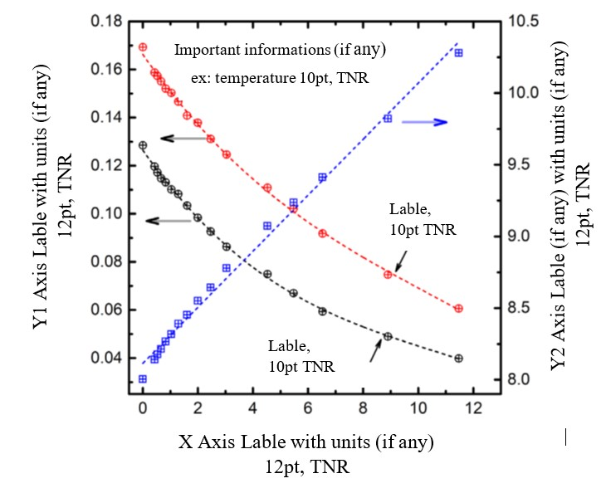
Figure 1: Figure caption/title (The figure caption should be 12 pt, Times New Roman font, left-justified, and appear immediately below the figure, with enough information to describe the figure)
Figure numbers should be indicated in the text as (Fig. 1) or Fig. 1, if it is a part of a sentence. If several figures are mentioned in the text, it would be "(Fig. 1 and 2) / (Fig. 1a, b and c)" or "Fig 1 and 2 / Fig. 1a and b", as appropriate.

REFERENCING
Use the author's surname followed by the publication date in brackets when following the Harvard method of in-text citations.
In-text citations example:
"The research was carried out from a social-constructivist perspective with child development seen as a process of guided participation (Rogoff, 2003). It thus adopted a transactional stance towards development that is culturally and historically constructed (Vygotskii, 1978)."
Reference Style

Book-one Author
Last name, First initial. (Year published). Title. Edition. (Only include the edition if it is not the first edition) City published: Publisher, Page(s).

Book-more Authors
Last name, First initial. And Last name, First initial. (Year published). Title. City: Publisher, Page(s).
Example:
Daniels, K., Patterson, G., and Dunston, Y. (2014). The ultimate student teaching guide. 2nd ed. Los Angeles: SAGE Publications, pp.145-151.

Print Journal Article
Last name, First initial. (Year published). Article title. Journal, Volume (Issue), Page(s).
Example
Dismuke, C. and Egede, L. (2015). The Impact of Cognitive, Social and Physical Limitations on Income in Community Dwelling Adults with Chronic Medical and Mental Disorders. Global Journal of Health Science, 7(5), pp. 183-195.

For additional information on formatting references, refer to the "Referencing Guidelines" under the "Quick links" section on the IRCUWU2023 website.

SUPPLEMENTARY GUIDELINES Equations
Equations should be centered and numbered consecutively, as in Eq. [1]. For long sets of equations where only one referencing equation number is wanted. Leave one line spacing before and after the equation.

1 𝑑³𝑏 [1]
𝐹 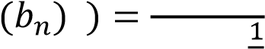² ∫ ^{𝑛} _{𝛿}⁴(𝐴−𝑏_{𝑛})
3𝜔^{𝑖}
(23𝜋)3
Describe symbols/constants that appear in the equation as needed.
Footnotes
Footnotes are denoted by a character superscript in the text ^{b}.

Units
Use only the SI units. Keep a single space between two types of units (e.g. J mol⁻¹ K⁻¹). Use a negative exponent (e.g., kg m⁻³) and do not indicate units as divisions (e.g., kg/m³).

Nomenclature
Follow IUPAC nomenclature in naming chemical substances.

Mathematical operations and mathematical equations keep a single space before and after arithmetic operators. e.g. 3 + 5 = 8
3 × 5 = 15 (Use the multiplication symbol, do not use the letter x or *)

Quantitative expression of scientific results
Keep a single space between the magnitude and the unit of a particular quantity. In expressing percentages, do not keep any space between the number and the % sign.
e.g. 5.00 × 10⁵ N m⁻², 56.7%

^{b} Just like this one.

Significant figures
In reporting experimental measurements, do not keep digits that are not significant (beyond the precision of the instrument's scale).
E.g., 4.6567 is to be reported as 4.66 if the scale used is precise up to the second decimal place.

Parenthesis
Keep a single space before and after the parenthesis. However, do not keep space between the first and the last letter/symbol inside the parenthesis. E.g., The magnitude of x is less than five (x < 5).

Lists
Lists can be provided using either numbers or bullets:
i. List item 1 like this; ii. List item 2 is an example of a more extended list item that wraps to a second line, where the second line is indented.

The example for bulleted items like this: • List item 1; • List item 2.

IMPORTANT: A PDF VERSION OF THE EXTENDED ABSTRACT
PREPARED ACCORDING TO THE GIVEN GUIDELINES SHOULD BE SUBMITTED THROUGH THE CMT SYSTEM BEFORE THE DEADLINE.

